Backend installation instructions

1. Download and install VS code, NodeJS, and MySQL workbench you may need to add “C:\Program Files\nodejs\” to the end of your Path variable on the "User variable" section of the Environment Variables on the System Properties. Or reboot after installing nodejs should fix issues later also.
2. Create local database schema named “discountmate” in MySQL workbench
3. Create table named “shops” with the settings as shown below

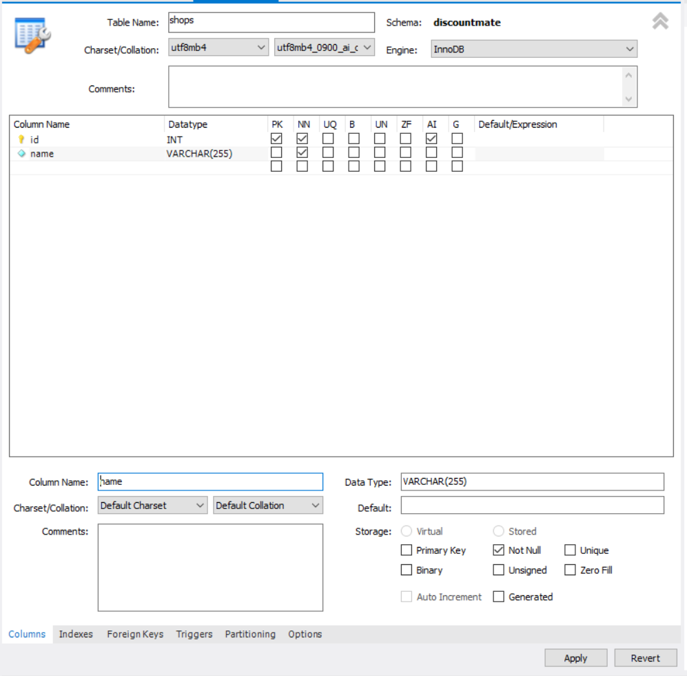

1. Add new user as shown below

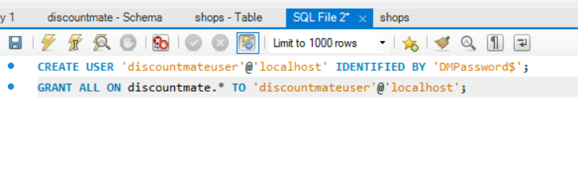

1. Add data to table

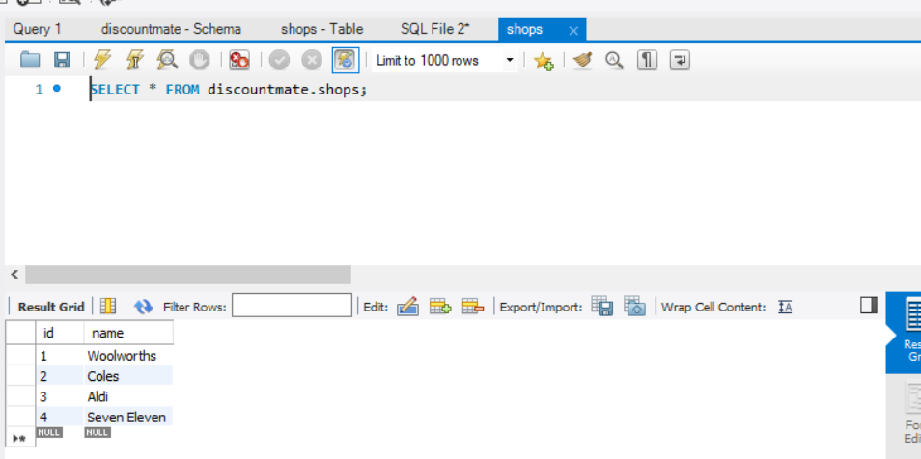

1. Open the “Backend” folder in visual studio code
2. Open a new terminal via the menu “Terminal > New Terminal”
3. Type in “npm install” to install all npm dependencies
4. Type “node index.js” to start the server, this will automatically open a web page at localhost:3000.